100W WHITE LED PAR64

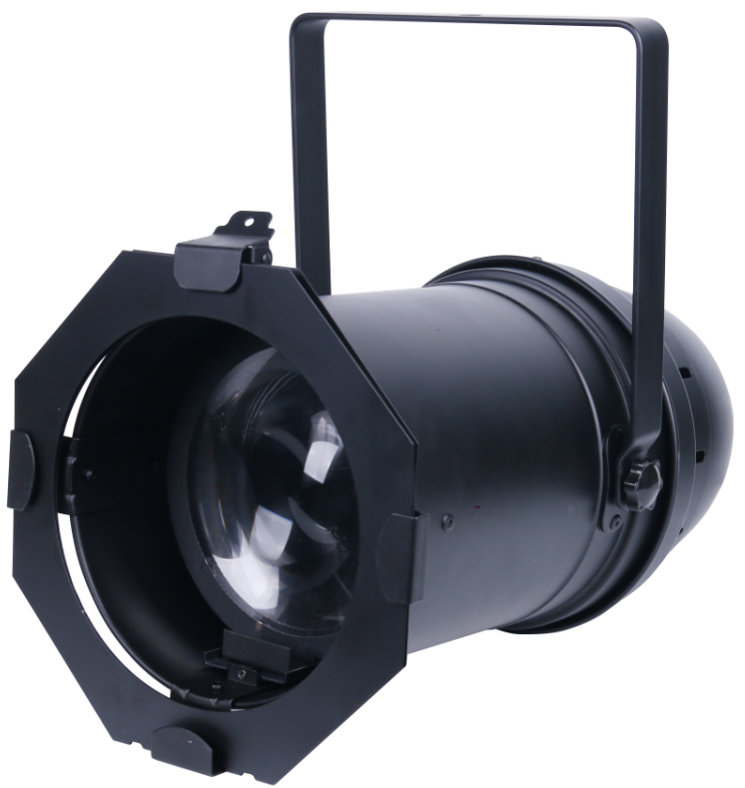

User Manual

Please read this manual carefully before use!
Thank you for purchasing our 100W COB WHITE LED PAR64. Please read user guide for safety and operations before using. Keep this manual for future reference.

1. Safety Instructions


- Please keep this User Manual for future consultation. If you sell the fixture to another user, be sure that they also receive this intruction booklet.
- Please unpack and check carefully there is no transportation damage before using the fixture.
- Please disconnect main power before servicing and mantenance.
- The unit must be installed in a location with adequate ventilation, at least 50cm from adjacent surfaces.Be sure that no ventilation slots are blocked.
- The maximum ambient temperature is Ta:40°C. DO NOT operate it where the temperature is higher than this.
- DO NOT connect the device to any dimmer pack.
- The housing must be replaced if they are visibly damaged.
- Unit surface temperature may reach up to 85°C. Don’t touch the housing bare-hand during its operation. Turn off the power and allow about 15 minutes for the unit to cool down before replacing or serving.
- There are no user serviceable parts inside the fixture. Do not open the housing or attempt any repairs by yourself. In the unlikely event your fixture may require service, please contact your nearest dealer.
- In the event of serious operating problem, stop using the fixture
Immediately. Never try to repair the fixture by yourself. Repairs carried out by unskilled people can lead to damage or malfunction. Please contact the nearest authorized technical assistance center. Always use the same type spare parts.

2. Safety Instructions

- 1/2/3 Channel Mode;
- Dimmer, Strobe;
- Ideal for Professional stages, Concerts, Clubs, Discotheques, Mobile Djs, etc.
- Input Voltage: AC100V~240V,50/60Hz
- Total Power consumption: 115W
- Beam Angle: Stepless manual zoom from 11°to 35°
- IP rating: IP20
- LED Sources: 100W White COB LED
- Color Temperature: 3000K/4000K/5700K for option.
- Product Dimension: 491x275x224mm
- Weight(N.W)： 3.4Kgs

3. Checking Parts

Please check if the following parts are included:
1pc x 100W par 64
1pc x Power cable
1pc x User manual

4. Installation and Connection

The unit should be mounted via its screw holes on the bracket. Always ensure that the unit is firmly fixed to avoid vibration and slipping while operating. Always ensure that the structure to which you are attaching the unit is secure and is able to support a weight of 10 times of the unit’s weight. Also always use a safety cable that can hold 12 times of the weight of the unit when installing the fixture.

The equipment must be fixed by professionals. And it must be fixed at a place where is out of the touch of people and has no one pass by or under it. The unit should be mounted in the height of 0 to 30m.

5. How to set the unit

Rear Panel
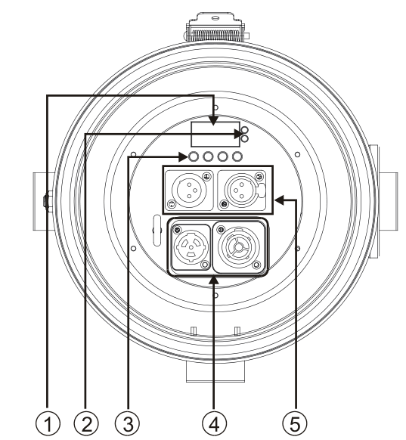

- Display : Show the various menus and the selected functions;
- LED indicator:
POWER | On | Power On
DMX | On | DMX input present
- Button:
MENU | To select the programming functions
DOWN | To go forward in the selected functions
UP | To go backward in the selected functions
ENTER | To confirm the selected functions
- Main input/output: PowerCon
- DMX input/output: For DMX512 link, use 3-pin XLR plug cable to input DMX signal, and to link the next unit.

The beam angle can be adjusted manually, stepless manual zoom from 11°to 35°
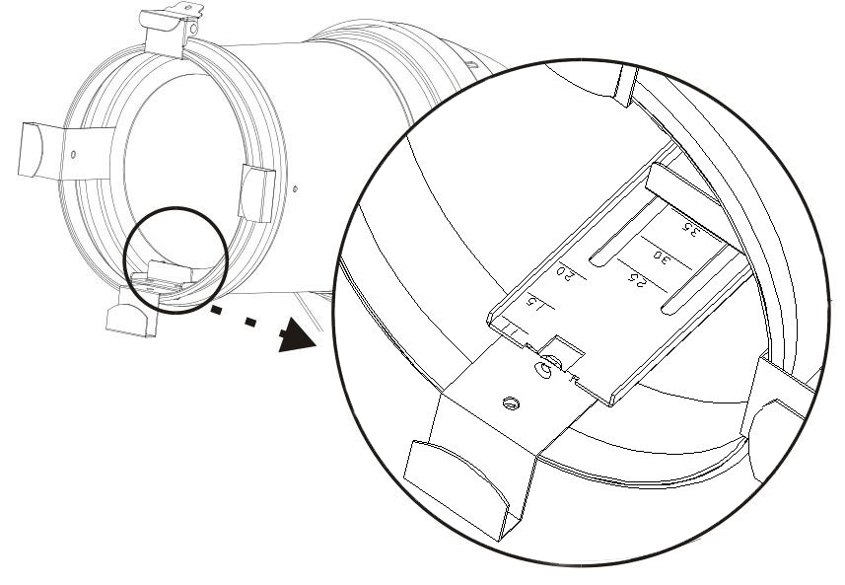
6. Main Function
To select any functions, press MENU button until the required one is shown on the display. Select the fuction by ENTER button. Use DOWN and UP button to change the mode. Once the required mode has been selected, press ENTER button to setup or it will return to the main functions without any change after idling 8 seconds automatically. Back to the functions without any change press MENU button.
The main function are shown below:
Main Menu | Sub Menu | Operation |  | Function | Remarks
MENU  (Nenu)  MENU  (Nenu) | Addr (set address) | enter | +/- | set address（001-512） | Press ENTER to confirm (save and exit)  Press ENTER to confirm (save and exit)
MENU  (Nenu)  MENU  (Nenu) | Chnd  (channel option) | enter | +/- | 1Ch
 |  |  |  | 2Ch
 |  |  |  | 3Ch
MENU  (Nenu)  MENU  (Nenu) | Dind  (dimmer) | enter | +/- | stda (standard scene)
 |  |  |  | stge (stage scene)
 |  |  |  | tv (TV scene)
 |  |  |  | aral (building scene)
 |  |  |  | thal (theatre scene)
MENU  (Nenu)  MENU  (Nenu) | Freq (dimmer frequency) | enter | +/- | 900Hz
 |  |  |  | 1000Hz
 |  |  |  | 1100Hz
 |  |  |  | 1200Hz
 |  |  |  | 1300Hz
 |  |  |  | 1400Hz
 |  |  |  | 1500Hz
 |  |  |  | 2500Hz
 |  |  |  | 4000Hz
 |  |  |  | 5000Hz
 |  |  |  | 10K
 |  |  |  | 15K
 |  |  |  | 20K
 |  |  |  | 25K
MENU  (Nenu)  MENU  (Nenu) | Gamma correction | enter | +/- | NO
 |  |  |  | 2
 |  |  |  | 2.2
 |  |  |  | 2.4
 |  |  |  | 2.6
 |  |  |  | 2.8
MENU  (Nenu)  MENU  (Nenu) | Slnd | enter | +/- | Mast (master)
 |  |  |  | Sl 1 (slave)
MENU  (Nenu)  MENU  (Nenu) | Lost | enter | +/- | blac
 |  |  |  | hold
 |  |  |  | auto
MENU  (Nenu)  MENU  (Nenu) | Manu | enter | +/- | d000-d255 ( manual dimmer 0-255)
MENU  (Nenu)  MENU  (Nenu) | Tenp (temperature) | enter |  | 00C-90C
MENU  (Nenu)  MENU  (Nenu) | Led (set backlight） | enter |  | on
 |  |  |  | off
MENU  (Nenu)  MENU  (Nenu) | disp (display reverse) | enter |  | on
 |  |  |  | off
MENU  (Nenu)  MENU  (Nenu) | Fhrs (working hours) | enter |  | total working hour
MENU  (Nenu)  MENU  (Nenu) | Ver (software version) | enter |  | software version
MENU  (Nenu)  MENU  (Nenu) | defa (set default) | enter |  | default

7. DMX512 configuration
Channel Mode:
1 Channel Mode
Channel | Function | Value | Details
CH1 | Dimmer | 000-255 | Master Dimmer 0-100%
2 Channel Mode
Channel | Function | Value | Details
CH1 | Dimmer | 000-255 | Master Dimmer 0-100%
CH2 | Strobe | 000-015 | Strobe on
CH2 | Strobe | 016-095 | Strobe （1HZ-25HZ Slow-Fast）
CH2 | Strobe | 096-175 | Strobe （1HZ Slow-Fast）
CH2 | Strobe | 176-255 | Random Strobe
3 Channel Mode
Channel | Function | Value | Details
CH1 | Dimmer | 000-255 | Master Dimmer 0-100%
CH2 | Dimmer_Fine | 000-255 | Fine dimmer
CH3 | Strobe | 000-015 | Strobe on
CH3 | Strobe | 016-095 | Strobe （1HZ-25HZ Slow-Fast）
CH3 | Strobe | 096-175 | Strobe （1HZ Slow-Fast）
CH3 | Strobe | 176-255 | Random Strobe

8. Troubleshooting
Following are a few common problems that may occur during operation. Here are some suggestions for easy troubleshooting:

- The fixture does not work, no light
1. Check the connection of power and main fuse.
2. Measure the mains voltage on the main connector.

B. Not responding to DMX controller
1. DMX LED should be on. If not, check DMX connectors, cables to see if link properly.
2. If the DMX LED is on and no response to the channel, check the address settings and DMX polarity.
3. If you have intermittent DMX signal problems, check the pins on connectors or on PCB of the fixture or the previous one.
4. Try to use another DMX controller.
5. Check if the DMX cables run near or run alongside to high voltage cables that may cause damage or interference to DMX interface circuit.

9. Fixture Cleaning

The cleaning of internal must be carried out periodically to optimize light output. Cleaning frequency depends on the environment in which the fixture operates: damp, smoky or particularly dirty surrounding can cause greater accumulation of dirt on the fixture’s optics.
- Clean with soft cloth using normal glass cleaning fluid.
- Always dry the parts carefully.
- Clean the external optics at least every 15 days. Clean the internal optics at least every 30/60 days.

